DNLC Lab-4

Worksheet: Sales Data

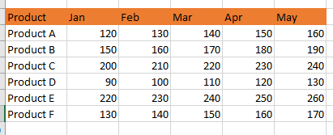

1. Use HLOOKUP to find the sales for Product A in March.



1. Use HLOOKUP to find the sales for Product D in May.

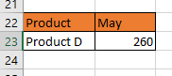

1. Use HLOOKUP to find the sales for Product C in February.

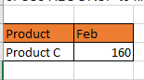

1. Use HLOOKUP to find the sales for each month for a product, then calculate the total sales for that product.

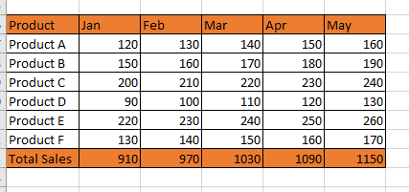

1. Use HLOOKUP to find the maximum sales value for Product B across all months.

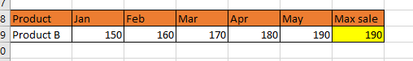

1. Use HLOOKUP to find the minimum sales value for Product F across all months.



1. Use HLOOKUP to find the average sales value for Product E across all months.

